|  |  |  |  |
| --- | --- | --- | --- |
| Artifact ID:  DJ-001 | Artifact Title:  Positioning System Decision Justification | |  |
| Revision:  1.0 | Revision Date:  22 OCT 2019 | |
| Prepared by:  Nick Merriman | | Checked by:  Checker |
| Purpose:  The purpose of this artifact is to clearly communicate the chosen concept for the positioning system and justify why the decision to use an off the shelf positioner was made. | | |

# Revision History

|  |  |  |  |
| --- | --- | --- | --- |
| Revision: | Revised by: | Checked by: | Date: |
| 1.0 | Nick Merriman | Checker | 22 OCT 2019 |

# References

|  |  |  |
| --- | --- | --- |
| Artifact ID: | Revision: | Title: |
| ID | 1.0 |  |

# Requirement Breakdown

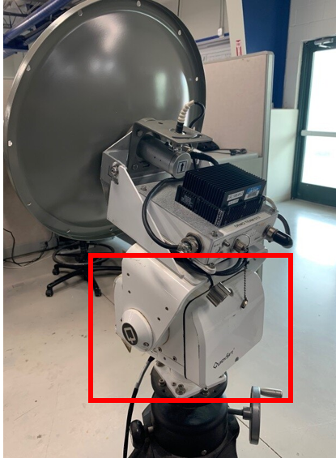**Concept Definition**

The positioning system refers to the components necessary to physically move the antenna used to communicate with the air vehicle. It does not include the computer hardware or software necessary to control the movement. The existing radar positioning system has a tilt and pan positioner which is being obsoleted, hence the need for this Capstone project. The current system can be seen below in figure 1, with the current positioner marked with a red rectangle. This is the primary piece of hardware which will be replaced as part of this project.

**Figure 1:** IMSAR’s current radar positioning system with the tilt and pan positioner marked with a red rectangle.

# Decision Justification

The team has decided to use an off the shelf positioner to physically move the radar positioning system’s antenna. IMSAR has offered to select and purchase a positioner to use. This will remove the necessity to develop and later manufacture our own positioner. This will allow IMSAR to feasibly produce this system, and virtually eliminate any manufacturing costs.

Using a commercially available positioner will significantly reduce the complexity of the project, as well as make it viable for IMSAR to use moving forward. By not having to design a positioner ourselves, the team will have more time to focus on the controls and making the positioner work as well as possible.

# Other Comments

As part of our concept development process alternative solutions were brainstormed. The brainstormed solutions are documented in ARTIFACT XXX. It was determined that using an off the shelf positioner is the most feasible option and will result in the best final product. Therefore, we will not be prototyping or pursuing other concepts related to the physical positioning system. This solution aligns with IMSAR’s desired solution.

IMSAR has communicated with us that the chosen positioner will not be available until January 2020. In order to begin prototyping and working on the control software an inexpensive pan-tilt-zoom camera has been purchased. The camera uses the same communication protocol as the final positioner that will be provided by IMSAR. This will facilitate prototyping earlier on and allow us to ultimately provide a better final product.